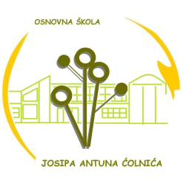

Osnovna škola Josipa Antuna Ćolnića Trg Nikole Šubića Zrinskog 4 Đakovo Tel: 031 816 665, 031 816 667, 031 817 014 Fax: 031 816 665
E-mail: ured@os-jacolnica-dj.skole.hr http://os-jacolnica-dj.skole.hr

Đakovo, 1. rujna 2023.

Raspored zvonjenja
ponedjeljak - petak
Nastavni sat - 45 min

1. 8:00-8:45
2. 8:55-9:40
3. 9:50-10:35
4. 10:40-11:25
5. 11:40-12:25
6. 12:40-13:25
7. 13:40-14:25
8. 14:30-15:15
9. 15:20-16:05

Ravnatelj:
Zvonko Belvanović

